LAB ASSIGNMENT-6.4
Task Description #1:
• Start a Python class named Student with attributes name, roll_number, and marks. Prompt GitHub Copilot to complete methods for displaying details and checking if marks are above average.
Expected Outcome #1:
• Completed class with Copilot-generated methods like display_details() and is_passed(), demonstrating use of if-else conditions.

Initial code:
class Student:
def __init__(self, name, roll_number, marks):
self.name = name
self.roll_number = roll_number
self.marks = marks
Prompt:

generate function display_details() to display the student details.generate is_passed() function to check if the student's marks are above the passing average (e.g., 50). give dynamic inputs
Complete code:
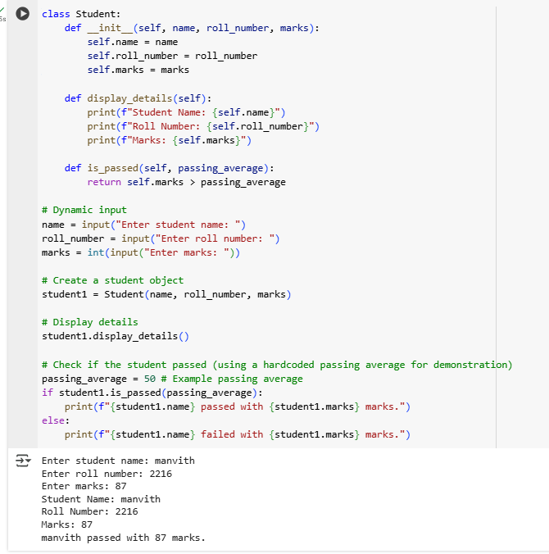
Task Description #2:
• Write the first two lines of a for loop to iterate through a list of numbers. Use a comment prompt to let Copilot suggest how to calculate and print the square of even numbers only.
Expected Outcome #2:
• A complete loop generated by Copilot with conditional logic (if number % 2 == 0) and appropriate output
Initial Code:
num= [1, 2, 3, 4, 5, 6, 7, 8, 9, 10]
for i in num:

Prompt:
Calculate the square of the even numbers and print them
COMPLETE CODE:
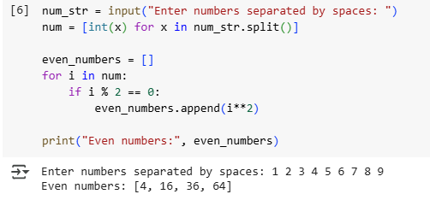
Task Description #3:
• Create a class called BankAccount with attributes account_holder and balance. Use Copilot to complete methods for deposit(), withdraw(), and check for insufficient balance.
Expected Outcome #3:
• Functional class with complete method definitions using if conditions and self attributes. Code should prevent overdrawing.
Initial code:
class BankAccount:
def __init__(self, account_holder, initial_balance=0):
self.account_holder = account_holder
self.balance = initial_balance
Prompt:
generate deposit(), withdraw(), and check for insufficient balance using if conditions and self attributes. give dynamic inputs
Complete code:
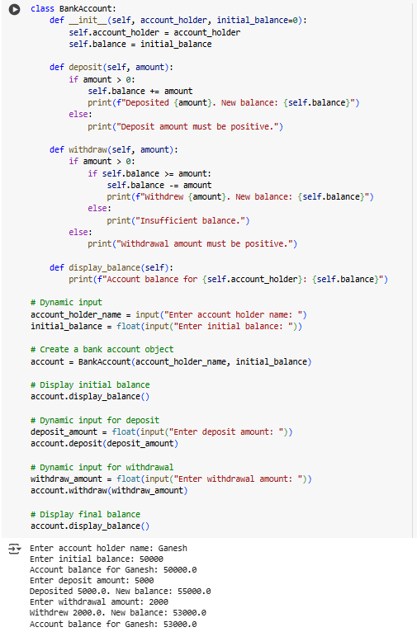

Task Description #4:
• Define a list of student dictionaries with keys name and score. Ask Copilot to write a while loop to print the names of students who scored more than 75.
Expected Outcome #4:
• A complete while loop generated by Copilot with proper condition checks and formatted output.

Prompt:
write a while loop to print the names of students who scored more than 75 with dynamic inputs.

Complete Code:
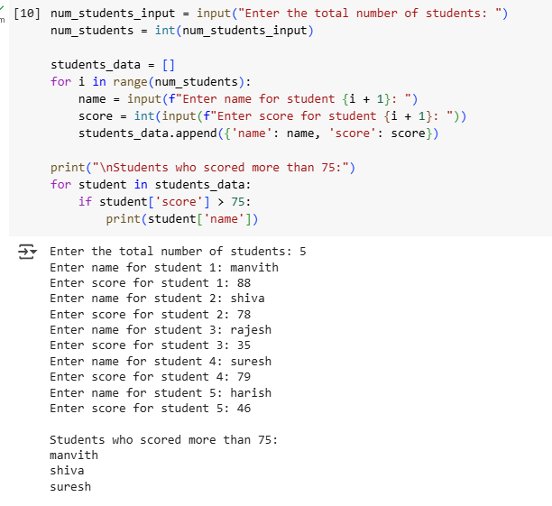
Task Description #5:
• Begin writing a class ShoppingCart with an empty items list. Prompt Copilot to generate methods to add_item, remove_item, and use a loop to calculate the total bill using conditional discounts.
Expected Outcome #5:
• A fully implemented ShoppingCart class with Copilot-generated loops and if-else statements handling item management and discount logic.

COMPLETE CODE:
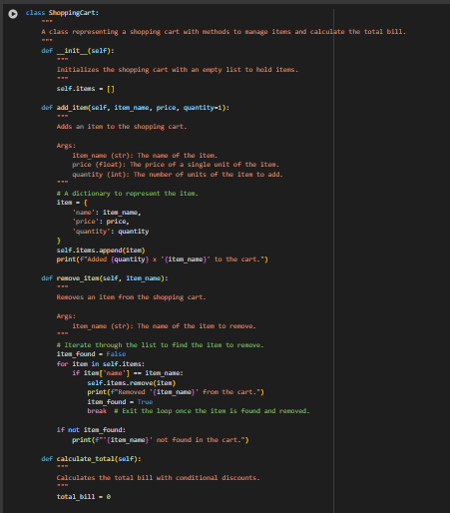

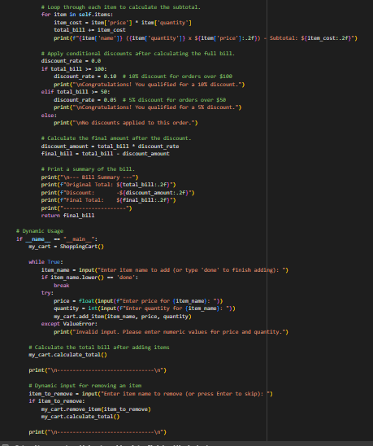
OUTPUT:
